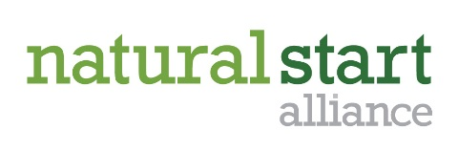
Call for Presentations

Nature-Based Preschool National Conference
August 15-17, 2016
Dodge Nature Center
West Saint Paul, MN

Name: Title:

Organization:

Mailing address:

City: State: Zip:

Phone: Email:

Co-presenter name: Title:

Organization:
*Please note all communication will be sent to the primary presenter listed.
Presentation Title:

Description of your presentation (150 words or less; this is strictly for the selection committee’s use):

Session program guide description (50 words or less; will be published to encourage participants to attend your session):

Please provide 2-3 objectives you hope to achieve in this session:

PLEASE CHECK ALL THAT APPLY

Please select your session type: Concurrent Session Facilitated Session Research Round Table
Note: Concurrent sessions are traditional presentation-style sessions by 1 or 2 presenters. Facilitated sessions are where a presenter provides a 10-15 minute overview of a topic and then facilitates a group discussion. All sessions will be 75-90 minutes depending on logistics. Research round tables will be 75 minute session to present research posters or information.

Please select the relevant track(s): Teachers Preschool administrators Nature Preschool 101*
*Nature Preschool 101 is intended to provide information for those just learning about nature-based preschools or those who don’t yet have a program, but are interested in starting one.

A/V Needs: LCD projector & screen Sound/speaker system Flip chart

Session setting: Primarily outdoor/experiential Primarily indoors Tables & Chairs Theater seating

Other needs/requests:

Call for presentations must be received by February 29, 2016. Due to space and time limitations, proposal submission does not guarantee acceptance. We will make every effort to accommodate your facility needs. Acceptance notifications will be provided by April 1, 2016 and accepted presenters will receive a $75 discount on conference registration. Questions and submissions should be sent to Sheila Williams Ridge, mailto:will0342@umn.edu

