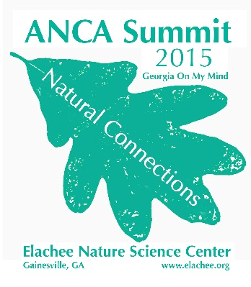
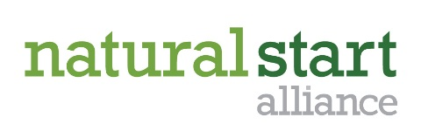
Call for Presentations

Nature-Based Preschool National Conference
August 19-22, 2015
Elachee Nature Science Center
Gainesville, Georgia

Name: Title:

Organization:

Mailing address:

City: State: Zip:

Phone: Email:

Co-presenter name: Title:

Organization:
*Please note all communication will be sent to the primary presenter listed.

Presentation Title:

Description of your presentation (150 words or less; this is strictly for the selection committee’s use):

Session program guide description (50 words or less; will be published to encourage participants to attend your session):

Please provide 2-3 objectives you hope to achieve in this session:

Please select your session type: Concurrent Session Facilitated Session
Note: Concurrent sessions are traditional presentation-style sessions by 1 or 2 presenters. Facilitated sessions are where a presenter provides a 10-15 minute overview of a topic and then facilitates a group discussion. All sessions will be 75-90 minutes depending on logistics.

Please select the relevant track(s): Teachers Preschool administrators Nature Preschool 101*
*Nature Preschool 101 is intended to provide information for those just learning about nature-based preschools or those who don’t yet have a program, but are interested in starting one.

A/V & Space needs: LCD projector & screen Sound/speaker system Flip chart Access to Outdoors

Other needs/requests:

Call for presentations must be received by February 20, 2015. Due to space and time limitations, proposal submission does not guarantee acceptance. Acceptance notifications will be provided by April 1, 2015. Questions and submissions should be sent to Rachel Larimore, rlarimore@chippewanaturecenter.org

